LEGAL RESEARCH
Class 5 Assignment
Please bring to class or otherwise have available.

- What a Riot
An unfortunate incident occurred during the last Baltimore Comic Con, held in Baltimore City, Maryland. A group of three Star Wars cos-players accosted several Star Trek fans on the vendor floor. The Star Wars group taunted the Star Trek crowd, waving their toy light sabers in an aggressive manner. During this affront, one of the Star Wars trio knocked over a vendor’s table of anime figures with her light saber, breaking several overpriced statuettes. The police arrested the Star Wars fans, who were charged with common law riot. Their case will be heard in the Baltimore City Circuit Court.
Was this boorish behavior an actual riot? Using Westlaw, find Maryland cases, binding on a trial court of that state, that specifically discuss and deal with the common law crime of riot.
- Using Westlaw Search for Maryland cases that discuss common law riot in some detail. FYI, this is the type of problem where proximity operators will be more a friend than natural language searching. Remember, where there is common law, usually a statute is not involved. List the cases you found below:

- Now, search using this keynumber but only for Maryland. Did you find any additional cases?

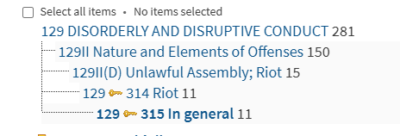

- Cat Scratch Fever
A friend’s cat scratched an overly affectionate social visitor. The injured person contracted a sickness they attribute to the scratch and is suing your friend. All this action occurred in the state of Connecticut. When is a cat’s owner liable for the critter lashing out and harming another?
- You have a Georgia case that deals with cat owner liability for injuries caused by their cuddly but temperamental pets. This is Fellers v. Carson, 356 S.E.2d 658 (Ga. Ct. App. 1987). Again, on Westlaw, use the key number in the Georgia case to search for cases in Connecticut (you will have to change the jurisdiction for the key number search). How many Connecticut cases can you come up with discussing liability for injuries from cats? You don’t have to read the cases closely but skim them for some key search terms. Include the citations below.

- Based on your skimming on the court cases you found through the key number above, come up with a search string that you could make for a search of Connecticut court cases. Try to come up with a reasonably precise search. Write your search string below and note how many cases your search returned.

