2.20.2025 In-Class Case Methods Activity
Read carefully:
Please answer the below questions using BLUE or GREEN. You have 40 minutes to get through this worksheet and you can use the database of your choice unless otherwise specified. If you spend more than 10 minutes on a section, call me over for a hint. This is ungraded but you must email me your work at the end of class.
I am going to release the answer key about an hour after class. I’d like everyone to grade their own answers before next class using a different color than the answers. Email the ‘graded’ sheet before class starts on Tuesday. Then we’ll talk about it during class.
If you finish early, email me your answers and I will immediately send you the answer key so you can use the remaining time in class to self-grade.

Finding from a statute:
MA ST 266 § 16 (copy/paste in Westlaw, navigate Mass Statutes in Lexis)
How many cases cite to this?
Westlaw 281, Lexis 224
How many of those cases are reported?
Westlaw 186, Lexis 179
How many reported cases have the word firearm anywhere in the text?
Westlaw 48, Lexis 50

Finding with West Key Numbers:
How many federal cases are indexed with the key number titled “purpose of elections” under the topic of “Election Law”?
142T Election Law> In General> Purpose of Elections: 5
How many Massachusetts cases are indexed with the key number that applies to the state’s general power to regulate public health?
198H Health> 198HII Public Health> 198H 351 Power to regulate> 198H 352 In General: 7
How many cases in Massachusetts are identified as dealing with the key number pertaining generally to administrative agencies and proceedings regarding environmental law?
149E Environmental Law>149EI In General>149E 14 Admin. Proceedings In General (8) >15 In General (4)
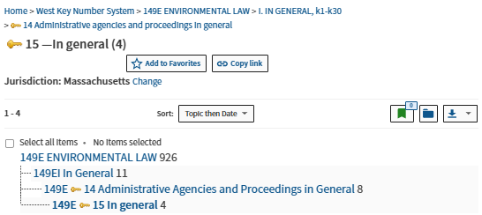

Finding from one good case:
Perez v. Mortg. Bankers Ass'n, 575 U.S. 92 (2015)
How many cases, total, cite to the above case?
Westlaw 526, Lexis 649
How many of those cases are from a First Circuit Court of Appeals?
Westlaw 3, Lexis 3
How many are from state courts?
Westlaw 29, Lexis 33
Narrow citing cases to the 9th Circuit Court of Appeals.
- How many of these 9th circ. Cases are reported?
  - Westlaw 19, Lexis 38

- Of these reported 9th Cir. Cases, how many mention the environment, environments, or environmental? What term should you use to find all of these.
  - Westlaw 10, Lexis 19, use environment! to search in the filter.

Finding from Lexis Notes of Decisions (Called Case Notes in one of our texts):
Click here: 17 U.S.C.S. § 302 (LexisNexis, Lexis Advance through Public Law 118-274, approved January 6, 2025, with a gap of Public Law 118-159)
Under which category can one find out whether extending the duration of existing copyrights is categorically beyond Congress’ authority under Copyright and Patent Clause of the U.S. Constitution?
Constitutionality
If an artist forgot to put a copyright notice on a CD-rom of her work, which case cited in NoDs would be helpful to consult?
Blair v. World Tropics Prods., No. 05-6083, 2007 U.S. Dist. LEXIS 113156 (W.D. Ark. May 17, 2007) (it’s the third paragraph under “generally.” The first, named case is part of the case history and is insightful for culpability, the second for awarding damages. Either would be fine for these purposes.)

Finding from Westlaw Notes of Decisions:
Please locate 15 U.S.C. § 15f on Westlaw to answer the following:
How many notes of Decisions?
12
Under 5. Disclosure of grand jury materials – Use of disclosed material, is there a supreme court opinion?
No—the supreme court citation is to a certiori denial.
Are any of these cases from within the last 6 months?
No.
How many are from the last 3 years?
1
How many would be binding (if relevant) on a federal district court in the second circuit?
5 – three from the 2d Circ. Court of App., 2 from the Supreme Court.

